Questions and Exercises to work out and turn in:

Grading Guidelines:

* A right answer will get full credit when:

1. It is right (worth 25%)
2. It is right **AND** neatly presented making it easy and pleasant to read. (worth an **extra** 15%)
3. There is an **obvious and clear link** between 1) the information provided in the exercise and in class and 2) the final answer. A clear link is built by properly writing, justifying, and documenting an answer (worth an **extra** 60%).
4. Calculation mistakes will be minimally penalized (2 to 5% of full credit) while errors on units will be more heavily penalized.

You are welcome/encouraged to discuss exercises with other students or the instructor. But, ultimately, **personal** writing is expected.

* USE THIS FILE AS THE STARTING DOCUMENT YOU WILL TURN IN. **DO NOT DELETE ANYTHING FROM THIS FILE:** JUST **INSERT** EACH ANSWER **RIGHT AFTER ITS QUESTION/PROMPT**.
* IF USING HAND WRITING (STRONGLY DISCOURAGED), **USE THIS FILE** BY CREATING SUFFICIENT SPACE AND WRITE IN YOUR ANSWERS.
* FAILING TO FOLLOW TURN IN DIRECTIONS /GUIDELINES WILL COST **A 30% PENALTY.**

Objectives of this assignment:

* to use and manipulate the concepts presented in this module
* to propose and write algorithms in pseudocode
* to analyze the time complexity of algorithms
* to analyze the space complexity of algorithms
* to learn autonomously new concepts

What you need to do:

Answer the questions and/or solve the exercises described below.

Exercise (100 points)

Sally proposes a different algorithm to the activity-selection problem: instead of always selecting the first activity to finish, she proposes to select the last activity to start that is compatible with all previously selected activities. Let us call this algorithm *Sally's Algorithm*.

1. (15 points) Describe how *Sally's Algorithm* is a greedy algorithm. Just using common sense, explain how this heuristic “makes sense”. (**Hint**: review in the lecture or on the textbook how the algorithm we studied is justified. Inspire and follow the same path to make your case)

Sally’s Algorithm is a greedy algorithm because at each step it makes the locally optimal choice, it chooses the last activity to start that doesn’t conflict with the already selected activities. This is based on the heuristic that by starting as late as possible, it leaves room for as many other activities as possible before it. This “makes sense” as a heuristic because it minimizes the wasted space at the end of the schedule.

1. (30 points) Execute *Sally's Algorithm* on the same problem studied in class with the same starting and finish times:

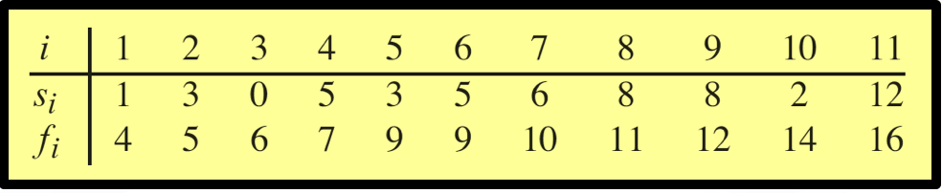

Explain in **detail** only how you determine the **first two** activities you select. Provide the set $S$ of activities *Sally's Algorithm* selects.

1. (40 points) Execute the iterative algorithm GREEDY-ACTIVITY-SELECTOR(s,f) (See Textbook p.421) on the same problem above. Explain in detail only how you determine the first two activities you select. Provide the set $S$ of activities GREEDY-ACTIVITY-SELECTOR(s,f) selects. Compare and discuss the sets of activities found by *Sally's Algorithm* and GREEDY-ACTIVITY-SELECTOR(s,f).
2. (15 points) **Prove** that it yields an optimal solution. Insure to follow the same steps used in the lecture to show that the greedy approach to select the earliest finish time activity that is compatible does deliver an optimal solution. Define well your notations just like the lecture (or textbook).

What you need to turn in:

* Electronic copy of this file (including your answers) (standalone). Submit the file as a Microsoft Word or PDF file.
* Recall that answers must be well written, documented, justified, and presented to get full credit.
* How this assignment will be graded:
* A right answer will get full credit when:
* It is right (worth 25%)
* It is right AND neatly presented making it easy and pleasant to read. (worth 15%)
* There is an obvious and clear link between 1) the information provided in the exercise and in class and 2) the final answer. A clear link is built by properly writing, justifying, and documenting an answer (worth 60%).
* Calculation mistakes will be minimally penalized (2 to 5% of full credit) while errors on units will be more heavily penalized.
* You are welcome/encouraged to discuss exercises with other students or the instructor. But, ultimately, personal writing is expected.

**Appendix**: Grading: What is an OBVIOUS and CLEAR LINK?

Here is an example to explain what an **obvious and clear link** is and how we grade your work.

Consider the following problem:

"(100 points) John travels from Auburn to Atlanta in his car at a speed of 60 mph. Leaving at 8am, at what time will John reach Atlanta".

Here are the answers of three students and their scores:

* **Student 1** answers: "9:48am". Student 1 will get 25 points.
* **Student 2**answers: "John will reach Atlanta at 9:48am". Student 2 will get 25+15 = 40 points
* **Student 3** answers: "The time t to travel a distance d at speed v is equal to d/v = d/60mph. The problem does not provide the distance d from Auburn to Atlanta. Based on GoogleMaps, the distance from Auburn to Atlanta is approximately 108 miles (**document is attached**).

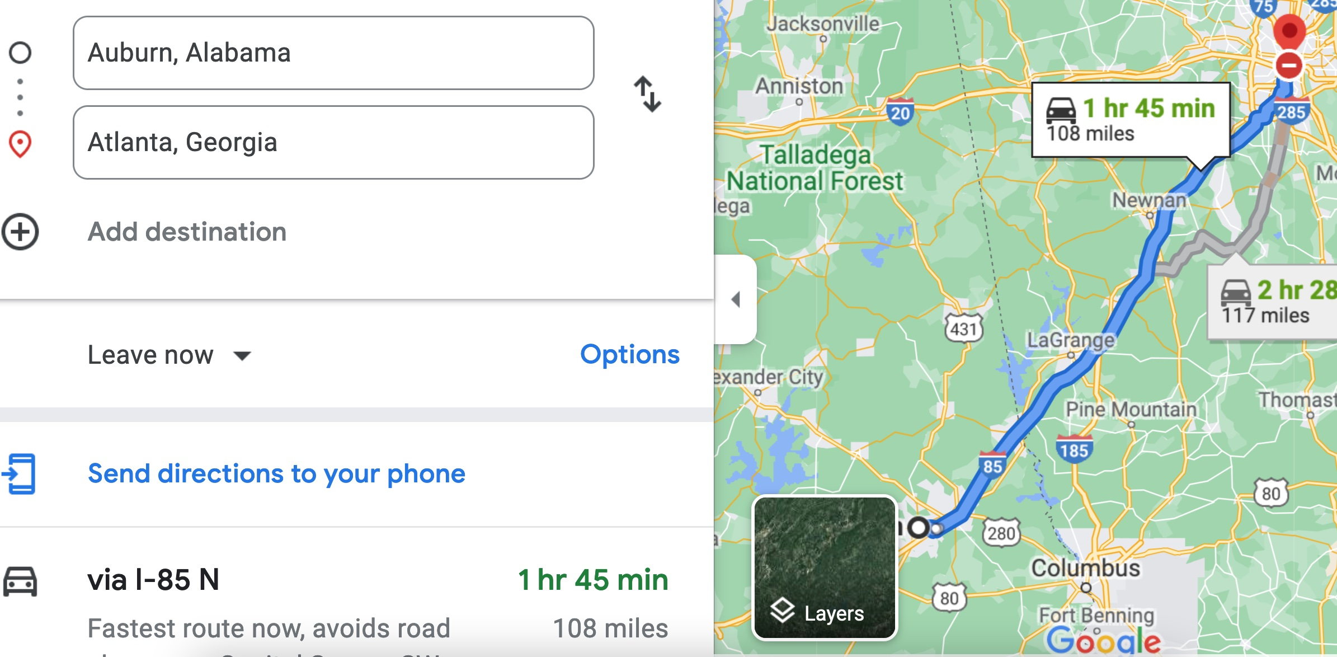

Therefore, the time t = 108 miles/60mph * 60 minutes/hour= 108 minutes. Since John left at 8am, he will then reach Atlanta at 8am + 108 minutes = 8 am + 60 minutes + 48 minutes = 9:48".

**Student 3** will get 25 + 15 + 60 = 100 points

Do you see the **direct** **link** going from the data provided in the question to the final answer, using general knowledge/formula and documents?.... Can you now solve the following problem and get 100 points?

"(100 points) Alice travels from Auburn to Atlanta in her car at a speed of 60 mph. Leaving at 8am, at what time will Alice reach Atlanta assuming that she had a flat tire that delayed her 30 minutes".